UBS – WLS PRIIPs documents design review
Valid for all languages (if the issue is language sensitive)

All below required changes have been applied to UBS Standard themes already
KID https://fe-tfs.visualstudio.com/Precision%20Plus/_workitems/edit/247752
PP https://fe-tfs.visualstudio.com/Precision%20Plus/_workitems/edit/248009
MP https://fe-tfs.visualstudio.com/Precision%20Plus/_workitems/edit/248010

Summary
If any of the changes below has been already applied to the current theme – please ignore the request.
This document summarizes all generic changes required and approved by UBS (for the Standard themes) in last time.
Those are required also for application in other (20+) underlying/cobranded-white labelled themes.
Therefor all requests are consolidated here (to be ignored if not applicable to given WL theme) - to avoid the risk of missing something.
Also some referred issues are not visible in current WL examples but can appear under specific conditions. Those are listed here as well and template review is required to avoid their appearance in any case.
Please release changes to the Staging environment only – for the testing and client review

KID
1.
Product section
- Make Manufacturer row in bold
- Make ISIN row not in bold
Before
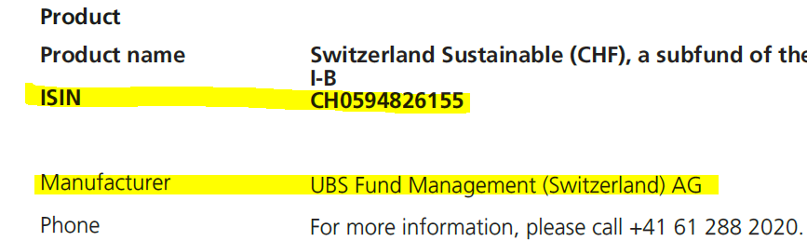

After
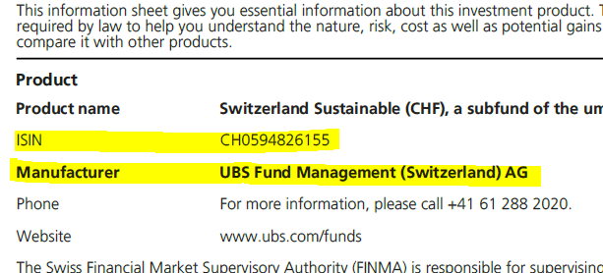

2.
Product section
Check the space between ISIN and Manufacturer rows (make the rows spacing same in entire section)
If the issue is not present please make sure to avoid it

- It is too big sometime – something needs to be reduced
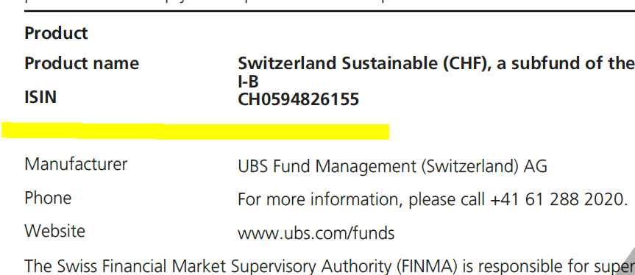

- And it is too small sometime – something needs to be added
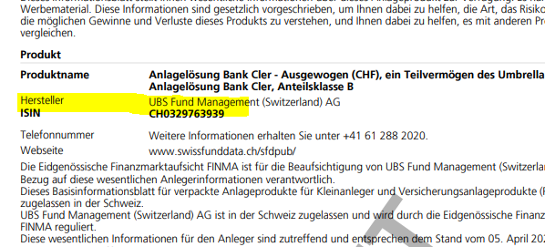
3.
Product section
Make ‘Complexity alert’ in bold – "WB_GeneralInformation_23"
After
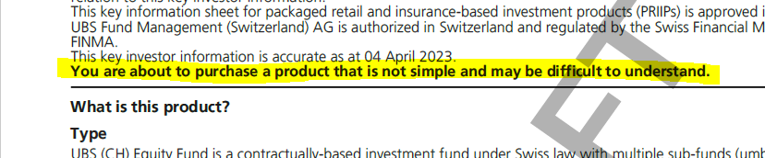

4.
Performance Scenarios table
Header of the table - make sure that the number and word ‘Year(s)’ will be always on the same row. Fix that in all columns of the table (their number changes)
If the issue is not present please make sure to avoid it

Before
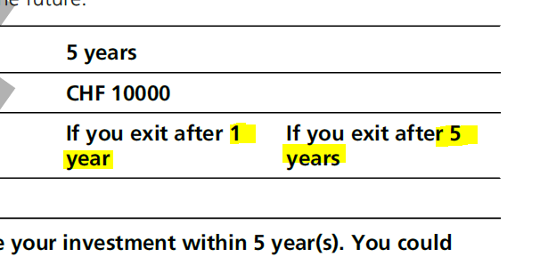
After
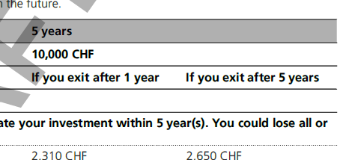

5.
Risk section
Make currency risk text in bold - "WB_SRInarrative2_34"
Before
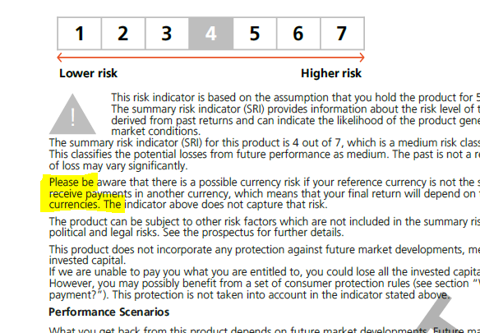
After
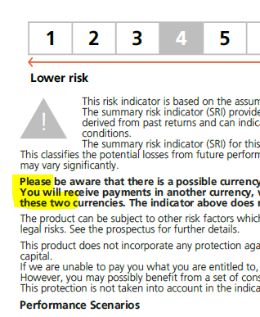

6.
Risk section – general lay out
- Place the triangle into the upper left corner of the text block
- Place the arrow and its legend below the box with numbers scale
- Avoid a page break inside the Risk (‘What are the risks and what could I get in return?’) section
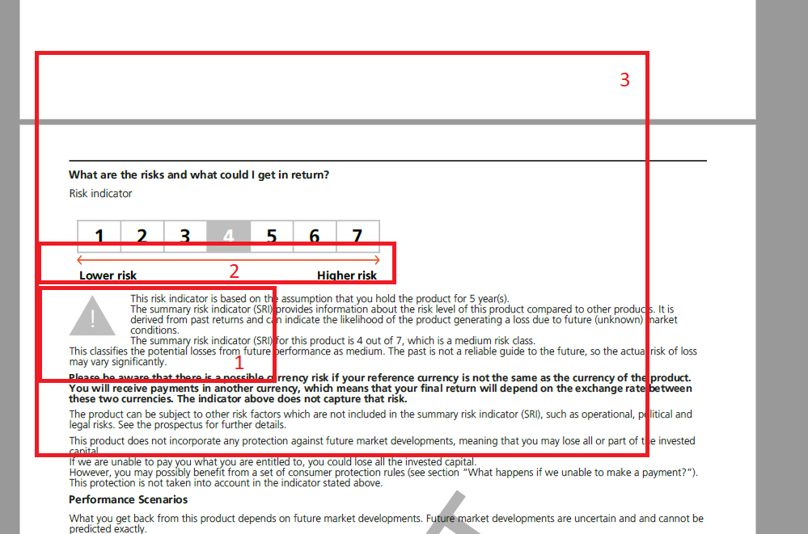
7.
Costs section
Avoid a page break inside the section
If the issue is not present please make sure to avoid it

Before (to be avoid) example
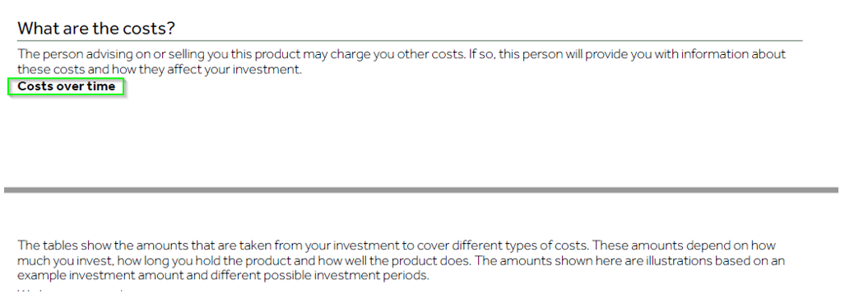
8.
Performance Scenarios table
Header – make text: ‘Recommended holding period:’ in bold

9.
Performance Scenarios table
Performance Scenarios table – make sure that the table header row (Recommended holding period:’ ….) is in the same format as e.g. Composition of costs table (background, border, fonts etc.)

10.
Costs composition table
Header of the table - make sure that the number and word ‘Year(s)’ will be always on the same row.
The same case as in other location as per the 4. above
If the issue is not present please make sure to avoid it

Example
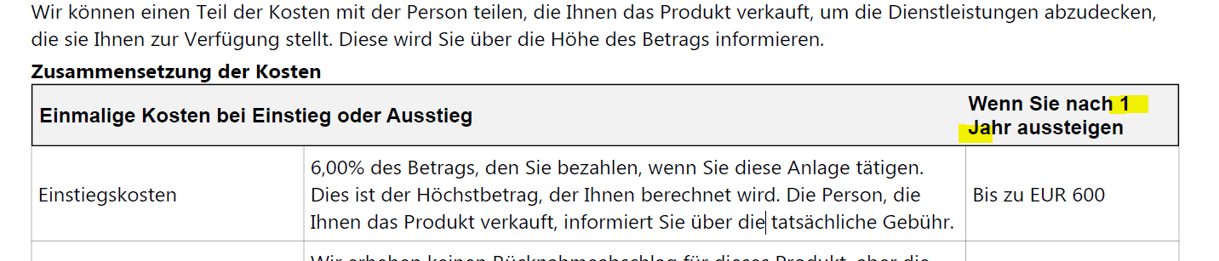

PP
1.
Table – legend to graph
Avoid split of text ‘Index *’ in two rows
If the issue is not present please make sure to avoid it

Before (to be avoid) example
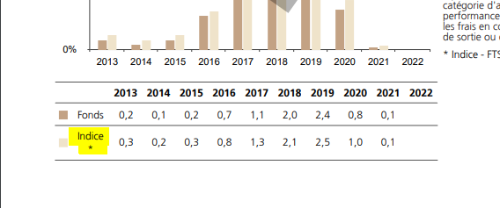

After (required)
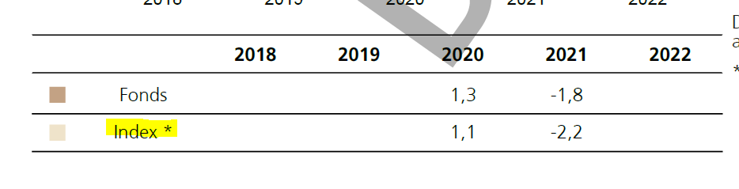
2.
Table – legend to graph
Review the table design – it is corrupted sometimes (apparently when some of the table cells hold no value)
If the issue is not present please make sure to avoid it

Issue (to be avoid) example
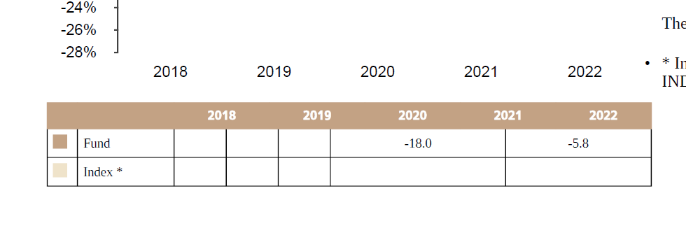
PDF example
3.
Graph – axis description – make sure that font used for axis descriptions is aligned with the document font requested by client.
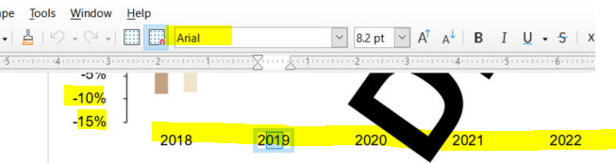

MP
1.
Table
Avoid unwanted random cutting of long words in the table header. It is most common in the German version of document.
German words identified causing the issue:
- Anlagebeispiel
- Herausbekommen
- Durchschnittliche
- Begünstigten
- Versichertes
If there is no other solution, make the font (for the table header only, not for the table data content!) slightly smaller. Please check the overlapping of columns to avoid situation like this:
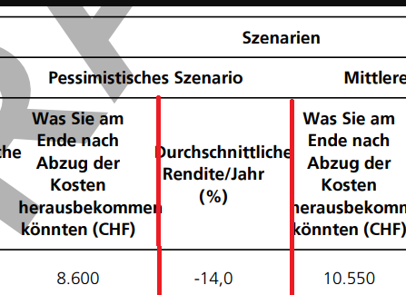

The example file (from UBS standard theme MP designing process https://fe-tfs.visualstudio.com/Precision%20Plus/_workitems/edit/248010 )

Result from there
